**This work is dedicated to all the farmers of the nation**

**ABSTRACT**

Our planet is progressively marching towards a serious electric energy crisis, owing to an escalating desire of electric energy becoming greater than its supply. We have always failed to accept that the energy we make use of each day is restricted, yet taking it for granted. Coal, petroleum, electric power, even water has inadequate availability. Nevertheless, we have not taken sufficient precautions to handle a possible energy crisis. Another main concern has been the lifespan of guided media and its loopholes to intercept and eavesdrop.

Agricultural sector has maintained a dominant position on economy and as a natural supply for the country. Understanding the effects of heat and humidity, rain and erosion is the need of the day. Given the recent technological improvements the world has seen, failing to make use of it would be a sin on mankind.

Here comes the need for a systematic hold on monitor of the data. As with the increase in technological innovations, so is the increase in required source power. An open minded effort would be to keep an eye on these available values from a remote location, interfacing a spot-on display, along with minimal power as possible.

**ACKNOWLEDGEMENT**

Any achievement, be it scholastic or otherwise does not depend solely on the individual efforts but on the guidance, encouragement and cooperation of intellectuals, elders and friends. A number of personalities, in their own capacities have helped us in carrying out this project work. We would like to take this opportunity to thank them all.

We express profound gratitude to respected principal **Dr. K. Mallikharjuna Babu,** BMS College of Engineering for providing a congenial environment to work in.

Our sincere gratitude to **Dr. D. Seshachalam,** Head of the Department, Electronics and Communication Engineering for encouraging and providing this opportunity to carry out the project in the department.

We would like to thank our guide **Mr. Harish V. Mekali,** Assistant Professor, Department of ECE who helped us in all the ways to carry out the project work. He stood beside and guided us in every step.

Our heartfelt thanks to **Dr. K. R. Suresh**, Professor, Dept. of Civil Engineering, for providing valuable information regarding agriculture and funding the complete project

Our special thanks to **Dr.Sadanand Gulwadi**, University Relation Manager, ARM, for providing the ARM MBED Cortex-M0 boards around which project has been built.

We will be incomplete, if we don't mention our heartfelt thanks to **Mr.Ashrith,** 5thSem, CSE, BMSCE for his expertise at Web Page development & the corresponding software parts**.**

We would like to share the joy completing the project to all the team members of NXP lab**.**

We thank all our professors for providing the basic knowledge without which this project wouldn't have been possible. Last but not the least we thank our family and friends, who made their valuable support compelled us to maintain a standard throughout our endeavour.

**SPONSOR DETAILS**

We are very much thankful to Visvesvaraya Technological University for funding the entire project.

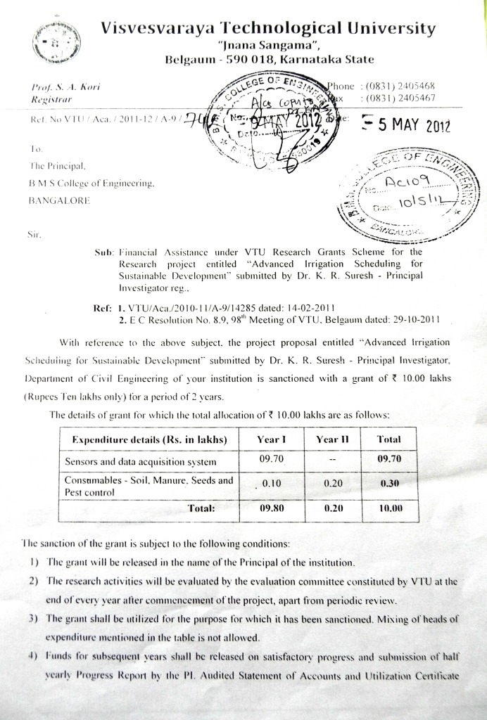

**TABLE OF CONTENTS**

**CHAPTER** **TOPIC PAGENO**

**- ABSTRACT 1**

**- ACKNOWLEDGEMENT 2**

**- LITERATURE SURVEY 5**

**1 INTRODUCTION 6**

**2 PROJECT FLOW 12**

**3 TESTING 31**

**4 CONCLUSION 45**

**5 RECOGNITION 46**

**- BIBLIOGRAPHY 48**

* **ANNEXURE 49**
* **APPENDIX 53**

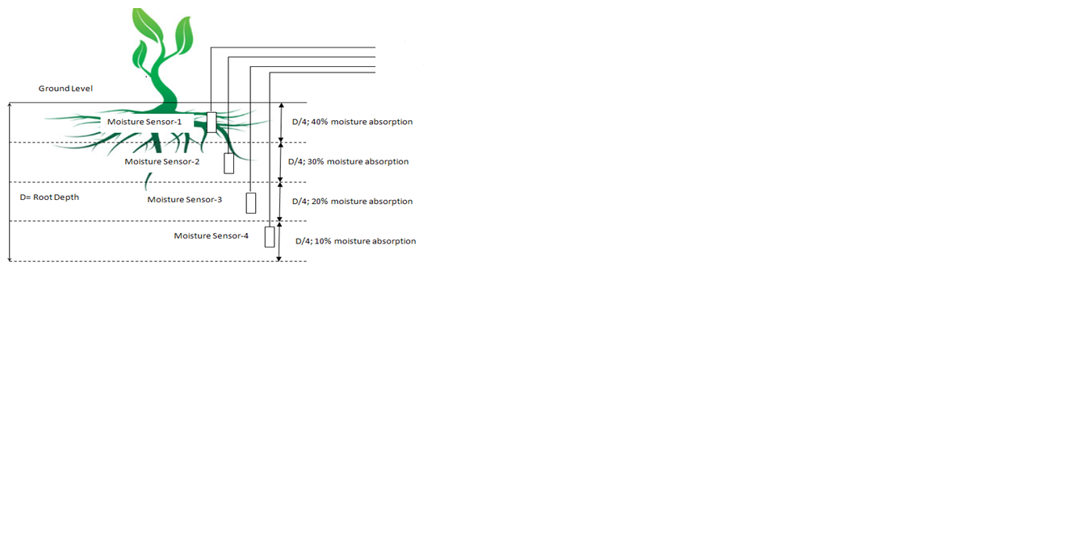

Data acquisition model

SIM900A

Display

Battery

optocoupler

Relay

Soil temperature sensor

Battery level indicator

**LITERATURE SURVEY**

1. ‘[Automated Irrigation System Using a Wireless Sensor Network and GPRS Module](http://ieeexplore.ieee.org/xpl/articleDetails.jsp?tp=&arnumber=6582678&queryText%3Dautomated+irrigation+system+using+a+wireless+sensor+network+and+gprs+module)’, By - [Gutierrez, J.](http://ieeexplore.ieee.org/search/searchresult.jsp?searchWithin=p_Authors:.QT.Gutierrez,%20J..QT.&newsearch=true), [Villa-Medina, J.F.](http://ieeexplore.ieee.org/search/searchresult.jsp?searchWithin=p_Authors:.QT.Villa-Medina,%20J.F..QT.&newsearch=true), [Nieto-Garibay, A.](http://ieeexplore.ieee.org/search/searchresult.jsp?searchWithin=p_Authors:.QT.Nieto-Garibay,%20A..QT.&newsearch=true), [Porta-Gandara M.A.](http://ieeexplore.ieee.org/search/searchresult.jsp?searchWithin=p_Authors:.QT.Porta-Gandara,%20M.A..QT.&newsearch=true)

* Knowledge on the design mainly consisting of wireless sensor network and wireless information unit that’s based on Zigbee technology and is realized using GPRS module and concentrated on low power consumption.
* Knowledge on achieving low power consumption using PIC.
* Knowledge on sensor network powered by solar panel with rechargeable battery that works for a longer time.
* Knowledge on UART interfaces with microcontroller that can accept the data with a speed of 115.2kbps from GPRS module.

1. ‘Smart Orchid Soil Moisture Monitoring System Based on Wireless Communication Technology’By- Ye Na & Liu Junfeng.

* Insight on the system cored with a Low-Power Microprocessor ‘MSP430f149 MCU’ which employs smaller radiations to the environment and human body.
* Insight on achieving a wide range of influence on soil moisture and intelligent control of data in a fixed memory.
* Insight on achieving a 24hr uninterrupted monitoring.
* Insight on serial non-volatile data memory chip for storage and display device, that is based on I2C bus, in turn using multifunctional memory chip of the ferroelectric technology which contains RTC.

1. ‘The optimizing design and application of a new wireless Low-power universal data acquisition system’ By­- Yan-fei ai1, yu-jie hao1, jian-ping li1.

* Perspective on breakthrough of traditional network communication by employing multi interface design consisting of Zigbee terminal, Zigbee router, Zigbee coordinator.
* Perspective on similar interface device connectivity with TI's chip TUSB3410 & integrated CS8900 Ethernet chip to support Ethernet interface to realize Ethernet communications; realizing serial port connectivity with PC.
* Perspective on optimization of data communication by avoiding data conflicts using hexagon method.

CHAPTER I

**INTRODUCTION**

Agriculture in [India](http://en.wikipedia.org/wiki/India) has a significant [history](http://en.wikipedia.org/wiki/History_of_agriculture). Today, India [ranks](http://en.wikipedia.org/wiki/List_of_countries_by_GDP_sector_composition) second worldwide in farm output. [Agriculture](http://en.wikipedia.org/wiki/Agriculture) and allied sectors like [forestry](http://en.wikipedia.org/wiki/Forestry_in_India) and [fisheries](http://en.wikipedia.org/wiki/Fishing_in_India) accounted for 16.6% of the total GDP of India in 2009 and considerably about 50% of the total workforce.

The economic contribution of agriculture to India's GDP is steadily declining with the country's broad-based economic growth. Still, agriculture is demographically the broadest economic sector and plays a significant role in the overall socio-economic fabric of India.

As Per the 2010 [FAO](http://en.wikipedia.org/wiki/Food_and_Agriculture_Organisation) ( **Food and Agriculture Organization of the United Nations**) world agriculture statistics, India is the world's largest producer of many fresh [fruits](http://en.wikipedia.org/wiki/Fruit) and vegetables, [milk](http://en.wikipedia.org/wiki/Milk), major [spices](http://en.wikipedia.org/wiki/Spice), select fresh meats, select fibrous crops such as [jute](http://en.wikipedia.org/wiki/Jute), several staples such as [millets](http://en.wikipedia.org/wiki/Millet) and [castor oil](http://en.wikipedia.org/wiki/Castor_oil) seed. India is the second largest producer of [wheat](http://en.wikipedia.org/wiki/Wheat) and [rice](http://en.wikipedia.org/wiki/Rice), the world's major [food staples](http://en.wikipedia.org/wiki/Staple_food). India is also the world's second or third largest producer of several [dry fruits](http://en.wikipedia.org/wiki/Dried_fruit), agriculture-based [textile](http://en.wikipedia.org/wiki/Textile) rawmaterials, [roots](http://en.wikipedia.org/wiki/List_of_root_vegetables) and [tuber](http://en.wikipedia.org/wiki/Tuber) crops, [pulses](http://en.wikipedia.org/wiki/Pulse_(legume)), [eggs](http://en.wikipedia.org/wiki/Egg_(food)), [coconut](http://en.wikipedia.org/wiki/Coconut), [sugarcane](http://en.wikipedia.org/wiki/Sugarcane) and numerous [vegetables](http://en.wikipedia.org/wiki/Vegetable). India ranked within the world's five largest producers of over 80% of agricultural produce items, including many [cash crops](http://en.wikipedia.org/wiki/Cash_crop) such as [coffee](http://en.wikipedia.org/wiki/Coffee) and [cotton](http://en.wikipedia.org/wiki/Cotton), in 2010. India is also one of the world's five largest producers of livestock and poultry meat, with one of the fastest growth rates, as of 2011.

Agriculture uses 85% of available fresh water resources worldwide and this percentage will continue to be dominant in water consumption because of population growth and increased food demand. There is an urgent need to create strategies based on science and technology for sustainable use of water, including technical, agronomic, managerial and institutional improvements.

Irrigation in India refers to the supply of water from Indian rivers, tanks, wells, canals and other artificial projects for the purpose of cultivation and agricultural activities. In country such as India, 64% of cultivated land is dependent on monsoons. The economic significance of irrigation in India is namely, to reduce over dependence on monsoons, advanced agricultural productivity, bringing more land under cultivation, reducing instability in output levels, creation of job opportunities, electricity and transport facilities, control of floods and prevention of droughts.

In addition to growth in total output, agriculture in India has shown an increase in average agricultural output per hectare in last 60 years. The table below presents average farm productivity in India over three farming years for some crops. Improving road and power generation infrastructure, knowledge gains and reforms has allowed India to increase farm productivity between 40% to 500% over 40 years.[[13]](http://en.wikipedia.org/wiki/Agriculture_in_India#cite_note-rbi1-13) India's recent accomplishments in crop yields while being impressive, are still just 30% to 60% of the best crop yields achievable in the farms of developed as well as other developing countries. Additionally, despite these gains in farm productivity, losses after harvest due to poor infrastructure and unorganised retail cause India to experience some of the highest food losses in the world.India and China are competing to establish the world record on rice yields.

For every 18 months the demand for electric based requirements increases two-fold.

The progress in electronic industries makes a little impact on concepts such as agriculture and concerns. The adaptability is respectively less by the farmers due to their lack in studies and growth of the world.

The proposed project has been our brain child on such aAgricultural Irrigation and Communication System. We have proudly maintained a check on power requirement without degrading the quality of it. This low power **‘Precision Agriculture’** system can be used in farm fields for acquiring the values of soil moisture and also temperature and humidity using sensors. These values can in turn be communicated to other farms else where such that they can be made proper use of as suggested so that the portability of the system increases.

### 1.1 WEATHER ****MONITORING SYSTEM****

We would like to begin by introducing our head start, another similar important project **‘WEATHER MONITORING SYSTEM’** by a fellow college mate Mr.Nithin whose work is based on monitoring the various factors of weather. We happily like to extend that this project has been successfully completed with the required outcomes matching his expectations.

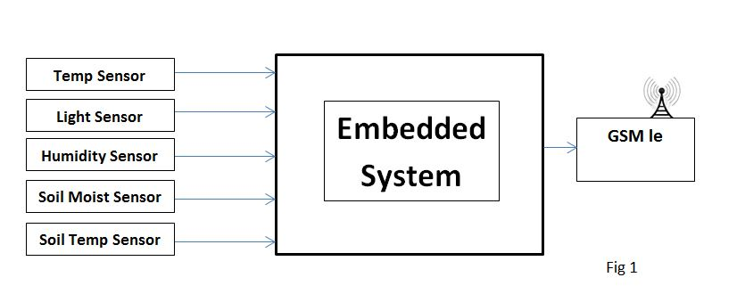

Fig 1.1(a): Depicts the transmitter part of the embedded system where the sensors read the values and sends them to a mobile phone in the form of SMS through GSM Module.

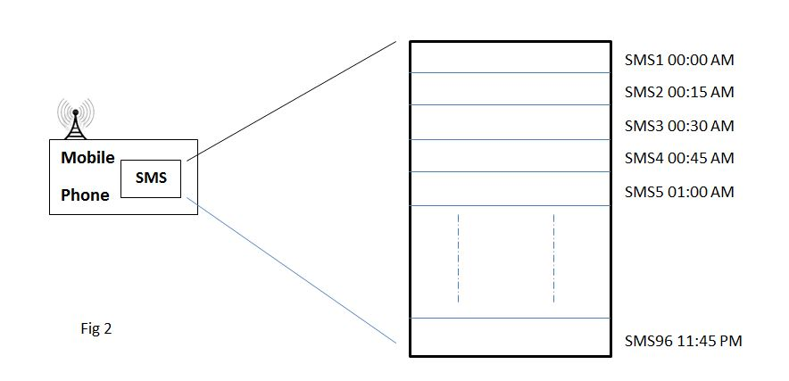

Fig 1.1(b): Receiver part of the embedded system where messages received for every 15 minutes will be stacked in the mobile storage.

SMS Format will be as given below.

Temp:290C SM:25% ST:180C Lum:100lux RH:20%

Fig 1.1(c): Output working whereget the graph of the corresponding parameter as shown above.

The aim of the project was to get the graph of the required parameter values.

## 1.2 Proposed Problem

India has very poor rural roads affecting timely supply of inputs and timely transfer of outputs from Indian farms. Irrigation systems are inadequate leading to crop failures in some parts of the country because of lack of water. In other areas regional floods, poor seed quality and inefficient farming practices, lack of cold storage and harvest spoilage cause over 30% of farmer's produce going to waste, lack of [organised retail](http://en.wikipedia.org/wiki/Retailing_in_India) and competing buyers thereby limiting Indian farmer's ability to sell the surplus and commercial crops.

The Indian farmer receives just 10 to 23% of the price the Indian consumer pays for exactly the same produce, the difference going to losses, inefficiencies and middlemen. Farmers in developed economies of Europe and the United States, in contrast, receive 64 to 81%.

This may not be an exactly concerned problem, yet the losses may look lesser if the profits are increased.

“No **‘Agricultural System’** at remote areasis perfect unless it works at a considerably low power and with change for modern equipment as per the change in technology& extended battery life at least for duration of year and more.”

It’s a need of the day that conventional electronics at Agricultural Farms overcome the clutches of old-school technology.

## 1.3 Diagnosed solution

Our innovation **“Precision Agriculture”** can be called as a successor of the above mentioned ‘**WMS’.**

As a sensible world resident, we begin by investigating alternative power solutions and advancement in technology, for example solar, wind electric energy and LDOs respectively. Utilizing these alternative energy solutions in as a whole is comparatively realistic and cheap to modern day units.

Technical solutions, previously accomplished using Analog circuitry, have been converted into data acquisition systems that translate Analog input signals into digital information and process the binary data. With a few additional ideas to decrease the power consumption by employing solar cells and the improved features provided by ARM such as ‘**Sleep Mode’** we lend a heavy help.

Also the employment of communicating techniques such as Zigbee Protocol and GSM-GPRS Combination takes care of the portability problem and lends support on remote wireless connectivity.

## 1.4 Implementation Model

**Microcontroller:** ARM Cortex M0 works as the heart of the project. It controls the output peripherals depending on the input sensor thresholds.

**Sensors:** Variety of sensors areused to detect the physical conditions of the environment such as moisture, temperature, humidity etc.

**LCD Display:** LCD 16x2 Display employed displays the various parameters of the sensors.

**Solar Panel– Battery:** The Solar panel helps in providing power by acquiring the energy from the Sun’s rays. This in-turn is fed to the battery employed for storage and future uses.

**Zigbee:**The communication part within different boards is accessed through the Zigbee Modules and its broadcasting protocol.

**GSM/GPRS:** A GPRS module is employed in the project such that the read values are not only displayed but also available online through the internet connection and as an SMS to the designated number. A combined GSM feature lets the values be accessed through the SMS (Short Message Service).

**RELAY & SOLENOID VALVE:**A DC Relay helps in switching the output mechanism (Solenoid Valve) ON/OFF as required, depending on the inputs (Sensors’ Values)

## 1.5 Block Diagram

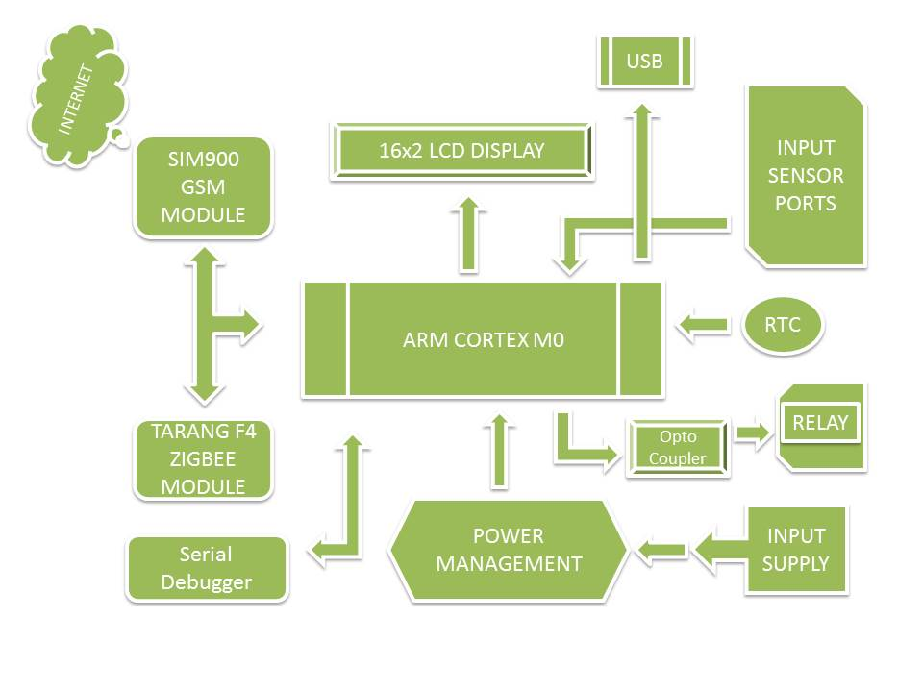

**Fig. 1.5** Conceptual block diagram of the model

CHAPTER- II

**PROJECT FLOW**

## **2.1 COMPONENTSUSED**

* ARM CORTEX MICROCONTROLLER
* SOIL MOISTURE SENSOR
* LCD DISPLAY
* OPTO-COUPLER
* RELAY
* ZIGBEE MODULE
* GSM MODULE
* REAL TIME CLOCK
* USB
* SOLAR PANEL

## 2.2 HARDWARES:

## 2.2.1 ARM CORTEX M0 LPC11U24:

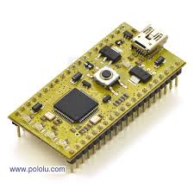

Fig. 2.2.1ARM Cortex-M0

## **2.2.2 General description**

* The LPC11U2x are an ARM Cortex-M0 based, low-cost 32-bit MCU family, designed for 8/16-bit microcontroller applications, offering performance, low power, simple instruction set and memory addressing together with reduced code size compared to existing 8/16-bit architectures.
* The LPC11U2x operate at CPU frequencies of up to 50 MHz
* Equipped with a highly flexible and configurable full -Speed USB 2.0 device controller, the LPC11U2x brings unparalleled design flexibility and seamless integration to today’s demanding connectivity solutions.
* The peripheral complement of the LPC11U2x includes up to 32 kB of flash memory, up to 10 kB of SRAM data memory and 4 kB EEPROM, one Fast -mode Plus I2C-bus interface, one RS-485/EIA-485 USART with support for synchronous mode and smart card interface, two SSP interfaces, four general- purpose counter/timers, a 10-bit ADC (Analogy-to-Digital Converter), and up to 54 general-purpose I/O pins.

## 2.4 LCD 16x2 DISPLAY

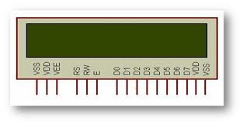

Fig. 2.4 LCD 16x2 Display

**LCD (Liquid Crystal Display**): A 16x2 LCD display is very basic module and is very commonly used in various devices and circuits. These modules are preferred over [seven segments](http://www.engineersgarage.com/content/seven-segment-display) and other multi segment [LED](http://www.engineersgarage.com/content/led)s. The reasons being: LCDs are economical; easily programmable; have no limitation of displaying special & even [custom characters](http://www.engineersgarage.com/microcontroller/8051projects/create-custom-characters-LCD-AT89C51) (unlike in seven segments) [animations](http://www.engineersgarage.com/microcontroller/8051projects/display-custom-animations-LCD-AT89C51) andsoon.

A **16x2 LCD** means it can display 16 characters per line and there are 2 such lines. In this LCD each character is displayed in 5x7 pixel matrix. This LCD has two registers, namely, Command and Data.

The command register stores the command instructions given to the LCD. A command is an instruction given to LCD to do a predefined task like initializing it, clearing its screen, setting the cursor position, controlling display etc. The data register stores the data to be displayed on the LCD. The data is the ASCII value of the character to be displayed on the LCD. Click to learn more about internal structure of a [LCD](http://www.engineersgarage.com/insight/how-lcd-works).

## 2.4.1 Pin Description:

|  |  |  |
| --- | --- | --- |
| **Pin No** | **Function** | **Name** |
| 1 | Ground (0V) | Ground |
| 2 | Supply voltage; 5V (4.7V – 5.3V) | Vcc |
| 3 | Contrast adjustment; through a variable resistor | VEE |
| 4 | Selects command register when low; and data register when high | Register Select |
| 5 | Low to write to the register; High to read from the register | Read/write |
| 6 | Sends data to data pins when a high to low pulse is given | Enable |
| 7 | 8-bit data pins | DB0 |
| 8 | DB1 |
| 9 | DB2 |
| 10 | DB3 |
| 11 | DB4 |
| 12 | DB5 |
| 13 | DB6 |
| 14 | DB7 |
| 15 | Backlight VCC (5V) | Led+ |
| 16 | Backlight Ground (0V) | Led- |

Table 2.4.1Pin description of LCD 16x2 Display

## 2.5 OPTO-COUPLER:

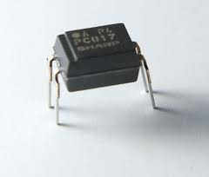

Fig. 2.5(a) Opto-Coupler IC

The HCPL-817 contains a light emitting diode optically coupled to a phototransistor. It is packaged in a 4-pin DIP package and available in wide-lead spacing option and lead bend SMD option. Input-output isolation voltage is 5000 Vrms. Response time, tr, is typically 4 µs and minimum CTR is 50% at input current of 5 mA.

**`**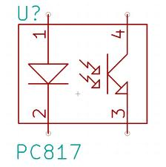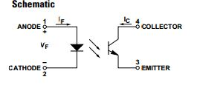

Fig. 2.5(b) Internal connection and schematic of Opto-Coupler IC PC817

**2.6 TARANG F4 ZIGBEE MODULE:**

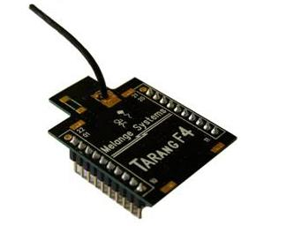

**Fig. 2.6** MELANGE TANRANG F4 ZIGBEE MODULE

ZigBee is a low-cost, low-power, wireless mesh network standard. The low cost allows the technology to be widely deployed in wireless control and monitoring applications. Low power usage allows longer life with smaller batteries. Mesh networking provides high reliability and more extensive range. ZigBee chip vendors typically sell integrated radios.

The ZigBee network layer natively supports both star and tree typical networks, and generic mesh networks. Every network must have one coordinator device, tasked with its creation, the control of its parameters and basic maintenance. Within star networks, the coordinator must be the central node. Both trees and meshes allow the use of ZigBee routers to extend communication at the network level.

Tarang F4 is one among a family of Zigbee Modules which are determined by their communication range precede Tarang F20 Zigbee Module and Tarang P20 Zigbee Module.

## Features and Benefits:

* Point to point, point to multi point, Mesh and peer-to-peer topologies on proprietary stack.
* Direct Sequence Spread Spectrum technology.
* Each direct sequence channel has 64K unique network addresses.
* Transmit Power: 0 dBs
* RF data rate: 250 kbps.
* Acknowledgement mode communication with retries.
* Power saving modes.
* Source / destination addressing.
* Unicast and broadcast communication.
* Analog to digital conversion and digital I/O line support.
* Default configuration for ready to use.

## Specifications:

# Power

|  |  |
| --- | --- |
| Supply Voltage | 3.3 to 3.6V |
| Transmit Current | 45mA |
| Idle/Receive Current | 50mA |
| Power-down Current | <10 µA |

# General

|  |  |
| --- | --- |
| Rating Frequency | ISM 2.4 - 2.4835 GHz |
| Maximum Transmit Power Output | 1mW (+0 dBm) |
| RF Data Rate | 250 kbps |
| Receiver Sensitivity | -92 dBm |
| Serial Interface Data Rate | Up to 115200 baud |
| Operating Temperature | -40 to 85 °C |
| Antenna Options | Chip Antenna, Wire Antenna |
| Antenna Connector | MMCX |

# Network

|  |  |
| --- | --- |
| Supported Network Topologies | Peer-to-peer, point to multipoint & Mesh |
| Number Of Channels | 16 direct sequence channels |
| Addressing Options | PAN ID, Channel and addresses |

# Mechanical

|  |  |
| --- | --- |
| Dimensions | 37mm x 26mm. |
| Interface Connector | 20 pin receptacles, 2.00mm pitch. |

A Wireless Distributed Network (WSN) has distributed[**autonomous**](http://en.wikipedia.org/wiki/Autonomous)[**sensors**](http://en.wikipedia.org/wiki/Sensor)tomonitorphysical or environmental conditions, such astemperature, sound,[**pressure**](http://en.wikipedia.org/wiki/Pressure), etc. and to cooperatively pass their data through the network to a main location. The WSN is built of "nodes" – from a few to several hundreds or even thousands, where each node is connected to one (or sometimes several) sensors.

ZigBee based wireless sensor networks have tremendous usage potential, because they are much more flexible in both installation and running operation mode than conventional wired networks. ZigBee wireless networks are adaptive and self-healing, that means these networks can withstand even hostile changes in the environment, like devices leaving the network due to hardware malfunctions or electromagnetic interferences.

The ZigBee specification puts very much emphasis on battery power conservation all the layers (physical, Media Access Control (MAC), network and application) from the ground up (IEEE 802.15.4) support this most important goal.

The standard specifies that a ZigBee End Device (ZED) must be able to operate at a minimum for 2 years on a single battery cell. The transmission is low data rate that means that while the maximum theoretical throughput between two devices can be up to around 250 kbps.

## 2.7 SIM900 GSM MODULE:

You need only two wires (TX, RX) except Power supply to interface with microcontroller / Arduino. The built in Power supply allows you to connect wide range unregulated power supply. Using this modem, you can send SMS, data and read SMS through simple AT command.

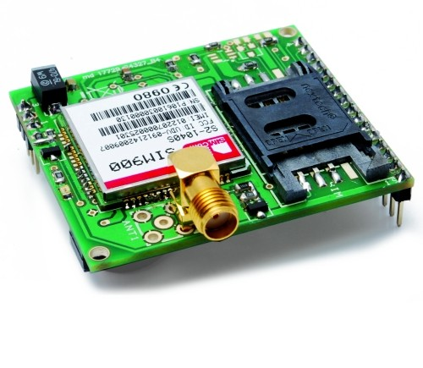

Fig. 2.6 SIM900 GSM MODULE

This is a complete Quad-band GSM/GPRS module in a SMT type and designed with a very powerful single-chip processor integrating AMR926EJ-S core, allowing you to benefit from small dimensions and cost-effective solutions.

Featuring an industry-standard interface, the SIM900 delivers GSM/GPRS 850/900/1800/1900MHz performance for voice, SMS, Data, and Fax in a small form factor and with low power consumption. With a tiny configuration of 24mm x 24mm x 3 mm, SIM900 can fit almost all the space requirements in your M2M applications, especially for slim and compact demands of design.

## 2.7 DC-12V RELAY:

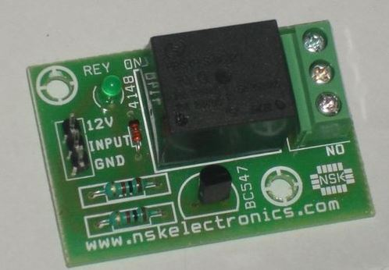

Fig. 2.7 Relay

A relay is an electrical switch that uses an electromagnet to move the switch from the off to on position instead of a person moving the switch. It takes a relatively small amount of power to turn on a relay but the relay can control something that draws much more power.

## 

## 2**.7.1 OPERATION OF RELAY:**

Relays (and switches) come in different configurations. The most common are shown to the right. Single Pole Single Throw (SPST) is the simplest with only two contacts. Single Pole Double Throw (SPDT) has three contacts. The contacts are usually labelled Common (COM), Normally Open (NO), and Normally Closed (NC). The Normally Closed contact will be connected to the Common contact when no power is applied to the coil. The Normally Open contact will be open (i.e. not connected) when no power is applied to the coil.

When the coil is energized the Common is connected to the Normally Open contact and the Normally Closed contact is left floating. The Double Pole versions are the same as the Single Pole version except there are two switches that open and close together. Select a relay with contacts that can handle the voltage and current requirements of the load. Keep in mind that some loads (such as motors) draw much more current when first turned on than they do at steady state. Select a relay with a coil voltage and current that you can control easily. Ex: If you want to turn on the AC unit with a 12VDC power supply get a 12VDC coil. Note: Coils will be rated for either AC or DC.

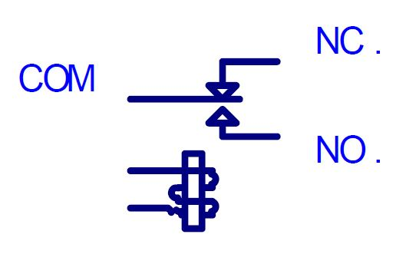

Fig. 2.7.1 Relay Operation

## 2.7.2 The primary functions of a relay are:

* The galvanic separation of the primary or actuating circuit and the load circuits
* Single input/multiple output capability
* Separation of different load circuits for multi-pole relays
* Separation of AC and DC circuits
* Interface between electronic and power circuits
* Multiple switching functions, e.g. delay, signal conditioning
* Amplifier function.

## 2.7.3 Applications of Relay:

Typical applications for relays include laboratory instruments, telecommunication systems, computer interfaces, domestic appliances, air conditioning and heating, automotive electrics, traffic control, lighting control, building control, electric power control, business machines, control of motors and solenoids, tooling machines, production and test equipment.

## 2.8 SENSORS:

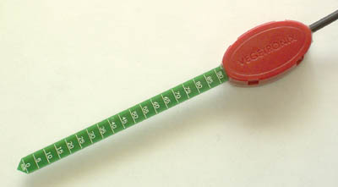

Fig 2.8VH400 Moisture sensor

## 2.8.1 Moisture Sensor:

High frequency VH400 series soil moisture sensor probes enable precise low cost monitoring of soil water content.  Because our probe measures the dielectric constant of the soil using transmission line techniques, it is insensitive to water salinity, and will not corrode over time as does conductivity based probes. Our probes are small, rugged, and low power.

Compared to other low cost sensor such as gypsum block sensors, our probes offer a rapid response time.  They can be inserted and take an accurate reading in under 1 second.

The VH400 operates at a much higher frequency and it is much more sensitive at higher VWC levels, and its curves are more linear.

Probes come standard with a 2 meter cable.

## 2.8.2 Soil Moisture Sensor Probe Applications:

* Irrigation and sprinkler systems.
* Moisture monitoring of bulk foods.
* Rain and weather monitoring.
* Environmental monitoring.
* Water conservation applications.
* Fluid level measurements.

## 2.8.3 Soil Moisture Sensor Probe Features:

* Extreme low cost with volume pricing.
* Not conductivity based.
* Insensitive to salinity.
* Probe does not corrode over time.
* Rugged design for long term use.
* Small size.
* Consumes less than 600uA for very low power operation.
* Precise measurement.
* Measures volumetric water content (VWC) or gravimetric water content (GWC).
* Patent pending technology.
* Output Voltage is proportional to moisture level.
* Wide supply voltage range.
* Can be buried and is water proof.
* Probe is long and slender for wider use, including smaller potted plants.

**2.9 REAL TIME CLOCK:**

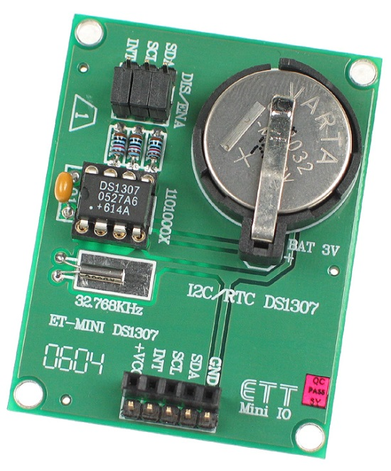

**Fig. 2.9** REAL TIME CLOCK

A **real-time clock** (**RTC**) is a [computer](http://en.wikipedia.org/wiki/Computer) [clock](http://en.wikipedia.org/wiki/Clock) (most often in the form of an [integrated circuit](http://en.wikipedia.org/wiki/Integrated_circuit)) that keeps track of the current [time](http://en.wikipedia.org/wiki/Time). Although the term often refers to the devices in [personal computers](http://en.wikipedia.org/wiki/Personal_computer), [servers](http://en.wikipedia.org/wiki/Server_(computing)) and [embedded systems](http://en.wikipedia.org/wiki/Embedded_system), RTCs are present in almost any electronic device which needs to keep accurate time.

RTCs often have an alternate source of power, so they can continue to keep time while the primary source of power is off or unavailable. This alternate source of power is normally a [lithium battery](http://en.wikipedia.org/wiki/Lithium_battery) in older systems, but some newer systems use a [supercapacitor](http://en.wikipedia.org/wiki/Supercapacitor)because they are rechargeable and can be [soldered](http://en.wikipedia.org/wiki/Soldering). The alternate power source can also supply power to [battery backed RAM](http://en.wikipedia.org/wiki/Nonvolatile_BIOS_memory).

Most RTCs use a [crystal oscillator](http://en.wikipedia.org/wiki/Crystal_oscillator) but some use the [power line frequency](http://en.wikipedia.org/wiki/Utility_frequency).In many cases the oscillator's frequency is 32.768 kHz. This is the same frequency used in[quartz clocks and watches](http://en.wikipedia.org/wiki/Quartz_clock), and for the same reasons, namely that the frequency is exactly 215 cycles per second, which is a convenient rate to use with simple binary counter circuits.

**Purpose:**

* Low power consumption(important when running from alternate power)
* Frees the main system for time-critical tasks
* Sometimes more accurate than other methods

**2.10 USB FLASH DRIVE CONNECTIVITY:**

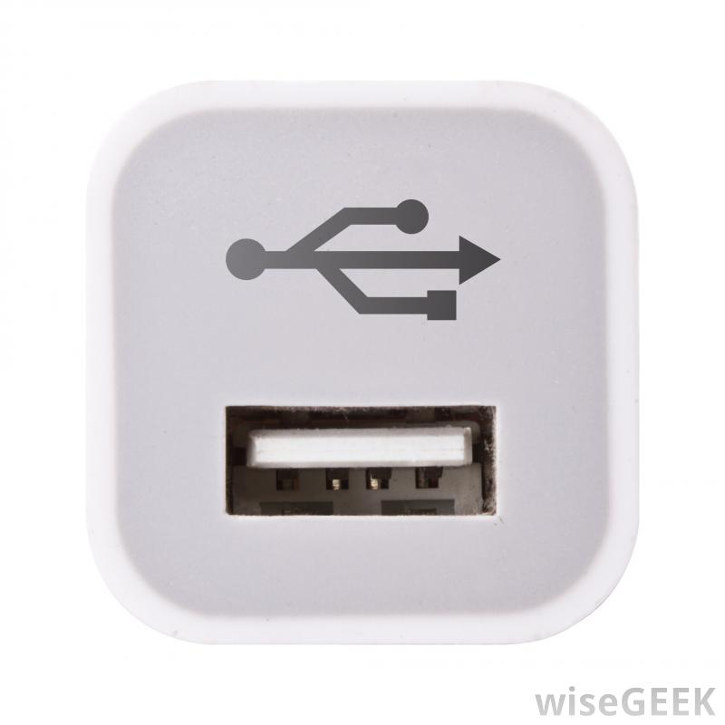

**USB FEMALE PORT USB FLASH DRIVE**

A **USB flash drive** is a [data storage device](http://en.wikipedia.org/wiki/Data_storage_device) that includes [flash memory](http://en.wikipedia.org/wiki/Flash_memory) with an integrated [Universal Serial Bus](http://en.wikipedia.org/wiki/Universal_Serial_Bus) (USB) interface. USB flash drives are typically removable and rewritable, and physically much smaller than an [optical disc](http://en.wikipedia.org/wiki/Optical_disc). Most weigh less than 30 grams (1.1 oz).

Storage capacities as large as 2 TB are planned, with steady improvements in size and price per capacity expected. Some allow up to 100,000 write/erase cycles, depending on the exact type of memory chip used, and a 10-year [shelf storage time](http://en.wikipedia.org/wiki/Digital_permanence).They are smaller, faster, have thousands of times more capacity, and are more durable and reliable because they have no[moving parts](http://en.wikipedia.org/wiki/Moving_parts).

Additionally, they are immune to magnetic interference (unlike floppy disks), and unharmed by surface scratches (unlike CDs). USB flash drives use the [USB mass storage](http://en.wikipedia.org/wiki/USB_mass_storage_device_class) standard, supported natively by modern [operating systems](http://en.wikipedia.org/wiki/Operating_system) such as [Linux](http://en.wikipedia.org/wiki/Linux), [OS X](http://en.wikipedia.org/wiki/OS_X), [Windows](http://en.wikipedia.org/wiki/Microsoft_Windows), and other [Unix-like](http://en.wikipedia.org/wiki/Unix-like) systems, as well as many [BIOS](http://en.wikipedia.org/wiki/BIOS) boot ROMs. USB drives with USB 2.0 support can store more data and transfer faster than much larger [optical disc drives](http://en.wikipedia.org/wiki/Optical_disc_drive).

A flash drive consists of a small [printed circuit board](http://en.wikipedia.org/wiki/Printed_circuit_board) carrying the circuit elements and a USB connector, insulated electrically and protected inside a plastic, metal, or rubberized case which can be carried in a pocket or on a key chain, for example.

The USB connector may be protected by a removable cap or by retracting into the body of the drive, although it is not likely to be damaged if unprotected. Most flash drives use a standard [type-A USB connection](http://en.wikipedia.org/wiki/Universal_Serial_Bus) allowing connection with a port on a personal computer, but [drives for other interfaces](http://en.wikipedia.org/wiki/USB_flash_drive#Flash_drives_for_non-USB_interfaces) also exist. USB flash drives draw power from the computer via the USB connection.

**Essential Components in an USB:**

* Standard-A USB plug – provides a physical interface to the host computer.
* USB mass storage controller – a small [microcontroller](http://en.wikipedia.org/wiki/Microcontroller) with a small amount of on-chip [ROM](http://en.wikipedia.org/wiki/Read-only_memory) and [RAM](http://en.wikipedia.org/wiki/Random_Access_Memory).
* [NAND flash](http://en.wikipedia.org/wiki/NAND_flash) memory chip(s) – stores data (NAND flash is typically also used in [digital cameras](http://en.wikipedia.org/wiki/Digital_camera)).
* [Crystal oscillator](http://en.wikipedia.org/wiki/Crystal_oscillator) – produces the device's main 12 MHz [clock signal](http://en.wikipedia.org/wiki/Clock_signal) and controls the device's data output through a [phase-locked loop](http://en.wikipedia.org/wiki/Phase-locked_loop).
* Cover - typically made of plastic or metal - to protect the electronics against mechanical stress and even possible short circuits

**2.11 SOLAR ENERGY HARVESTING:**

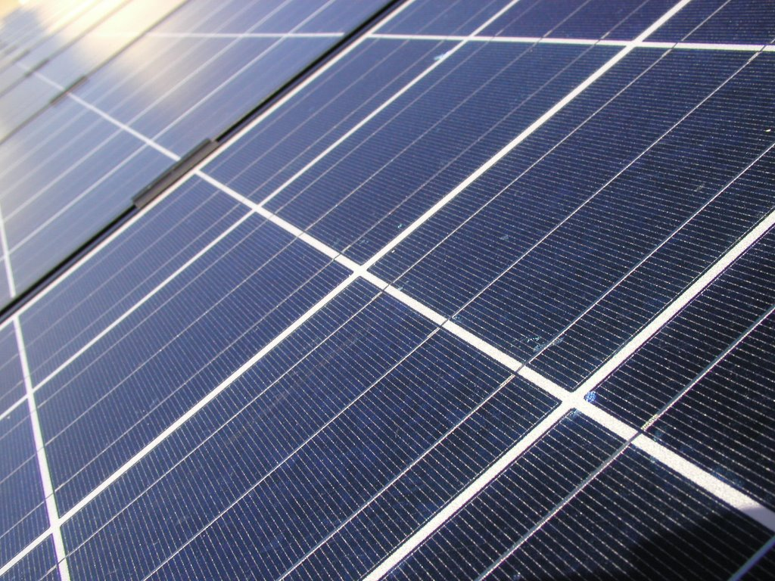

**Fig. 2.11(A) SOLAR PANEL**

**Solar energy**, radiant [light](http://en.wikipedia.org/wiki/Light) and [heat](http://en.wikipedia.org/wiki/Heat) from the [sun](http://en.wikipedia.org/wiki/Sun), is harnessed using a range of ever-evolving technologies such as [solar heating](http://en.wikipedia.org/wiki/Solar_heating), [solar photovoltaics](http://en.wikipedia.org/wiki/Solar_photovoltaics), [solar thermal electricity](http://en.wikipedia.org/wiki/Solar_thermal_electricity), [solar architecture](http://en.wikipedia.org/wiki/Solar_architecture) and [artificial photosynthesis](http://en.wikipedia.org/wiki/Artificial_photosynthesis).

Solar technologies are broadly characterized as either [passive solar](http://en.wikipedia.org/wiki/Passive_solar) or [active solar](http://en.wikipedia.org/wiki/Active_solar) depending on the way they capture, convert and distribute solar energy. Active solar techniques include the use of photovoltaic panels and [solar thermal](http://en.wikipedia.org/wiki/Solar_thermal_energy) collectors to harness the energy. Passive solar techniques include orienting a building to the Sun, selecting materials with favourable [thermal mass](http://en.wikipedia.org/wiki/Thermal_mass) or light dispersing properties, and designing spaces that [naturally circulate air](http://en.wikipedia.org/wiki/Ventilation_(architecture)).

The Earth receives 174 [petawatts](http://en.wikipedia.org/wiki/Orders_of_magnitude_(power)#petawatt_.281015_watts.29) (PW) of incoming solar radiation ([insolation](http://en.wikipedia.org/wiki/Insolation)) at the upper [atmosphere](http://en.wikipedia.org/wiki/Earth%27s_atmosphere). Approximately 30% is reflected back to space while the rest is absorbed by clouds, oceans and land masses. The [spectrum](http://en.wikipedia.org/wiki/Electromagnetic_spectrum) of solar light at the Earth's surface is mostly spread across the [visible](http://en.wikipedia.org/wiki/Visible_light) and [near-infrared](http://en.wikipedia.org/wiki/Near-infrared) ranges with a small part in the [near-ultraviolet](http://en.wikipedia.org/wiki/Near-ultraviolet).Solar energy can be harnessed at different levels around the world, mostly depending on distance from the equator.

|  |
| --- |
| **Yearly Solar fluxes & Human Energy Consumption** |
| Solar | 3,850,000 [EJ](http://en.wikipedia.org/wiki/Joule#Multiples)[[8]](http://en.wikipedia.org/wiki/Solar_energy#cite_note-Smil_2006.2C_p._12-8) |
| Wind | 2,250 EJ[[9]](http://en.wikipedia.org/wiki/Solar_energy#cite_note-9) |
| Biomass potential | 100–300 EJ[[10]](http://en.wikipedia.org/wiki/Solar_energy#cite_note-fa.upc.es-10) |
| Primary energy use (2010) | 539 EJ[[11]](http://en.wikipedia.org/wiki/Solar_energy#cite_note-11) |
| Electricity (2010) | 66.5 EJ[[12]](http://en.wikipedia.org/wiki/Solar_energy#cite_note-12) |

**Fig. 2.11(B)** Table of Energy Dividends

The project employs the benefits of solar energy harvesting once the input supply specifications are finalized. Using solar energy optimizes the circuit functions further more since the input supply power is minimized as far as possible. Also this brings a certain value to the project.

Chapter III

**TESTING**

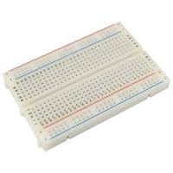

Fig 3.0 General representation of a Bread-Board

We initiated our idea on a General Bread-Board at the beginning. Our academics helped us to understand the basic model of a bread-board such that the connections upon it can be carried on with ease. Understanding of the internal connections is an important aspect with respect to the connections made upon it.

As a launching pad and a board on which we could work out our experiments, we carried out our initiation in a general 32x14 Bread-Board as we had a distinct knowledge working on these.

The overall project was carried forward by mounting the corresponding components on the Bread-Board as per the schematic later presented.

**3.1ARM CORTEX M0:**

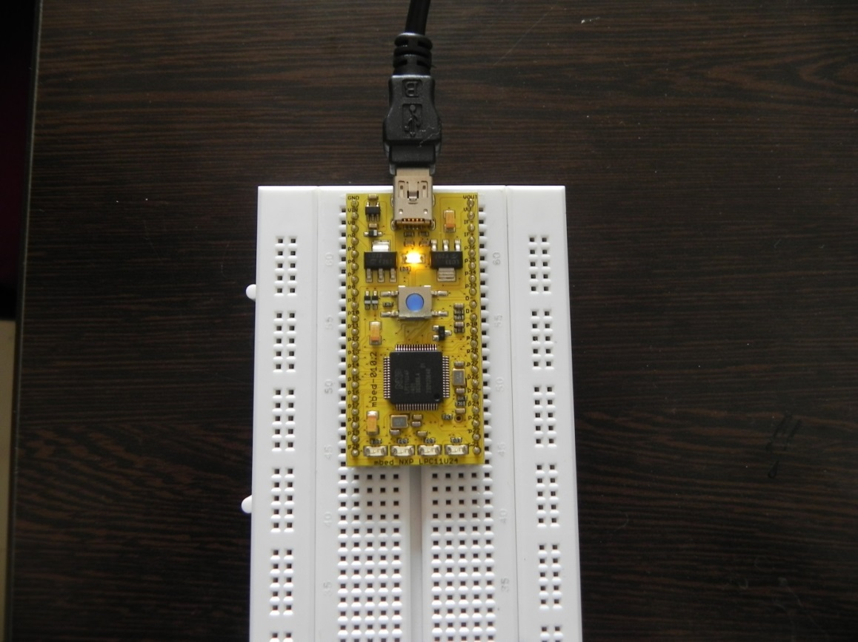

Fig 3.1 An ARM IC on a bread board

ARM Cortex was the utmost main component that we wished to test first by embedding it on the bread-board and through the interfacing of USB connector. It was tested by using our knowledge of the online compiler.

The purpose to use ARM Cortex- M0 is because of the fact that it is the lowest power consuming IC available from the family of ARM Controllers.

## 3.2 LCD DISPLAY:

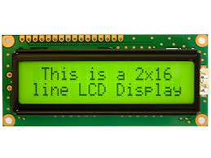

Fig. 3.2 LCD 16x2 Display

The next step of our testing was occupied by the output device ‘LCD 16x2 Display’. We found it more important to display our outcomes through a device that can be more of an understanding to the outward world.

We even went to the extent of displaying our names quite naively.

## 3.3 Opto-coupler and Relay:

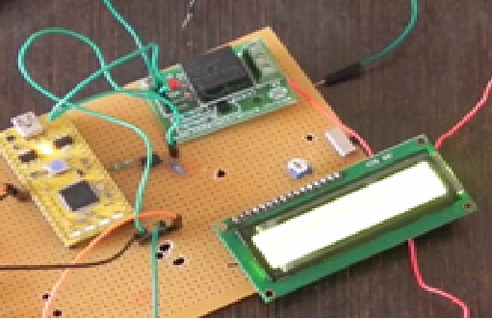

Fig 3.3 Connection of Opto-coupler and relay

We followed the interfacing cycle next by an opto-coupler. We followed it up with a relay to drive the solenoid valve. The main reason for using this opto-coupler was to provide isolation between the relay and the controller on one side. Also when the solenoid valve turns on it produces a back-emf which may turn out to be harmful to the controller. So in order to provide this very required isolation we employed the opto-coupler.

## 3.4 Sensors:

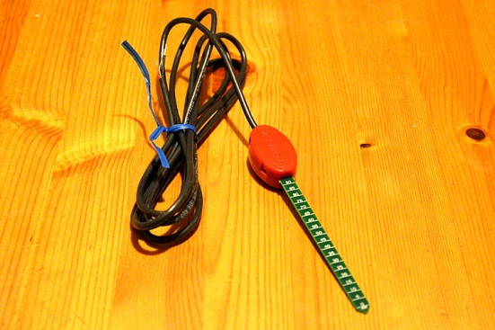

**Fig. 3.4 VH-400 Soil Moisture Sensor**

Our need was fed by the values from the sensors that we employed. The moisture sensor was used to sense the moisture level of the soil which was in turn fed to the controller. We set a calibrating threshold as per our required level. The programming was such that when the sensor value moisture exceeded the threshold the controller provided the control signal to turn off the solenoid valve.

## 3.5 Final Working Model:

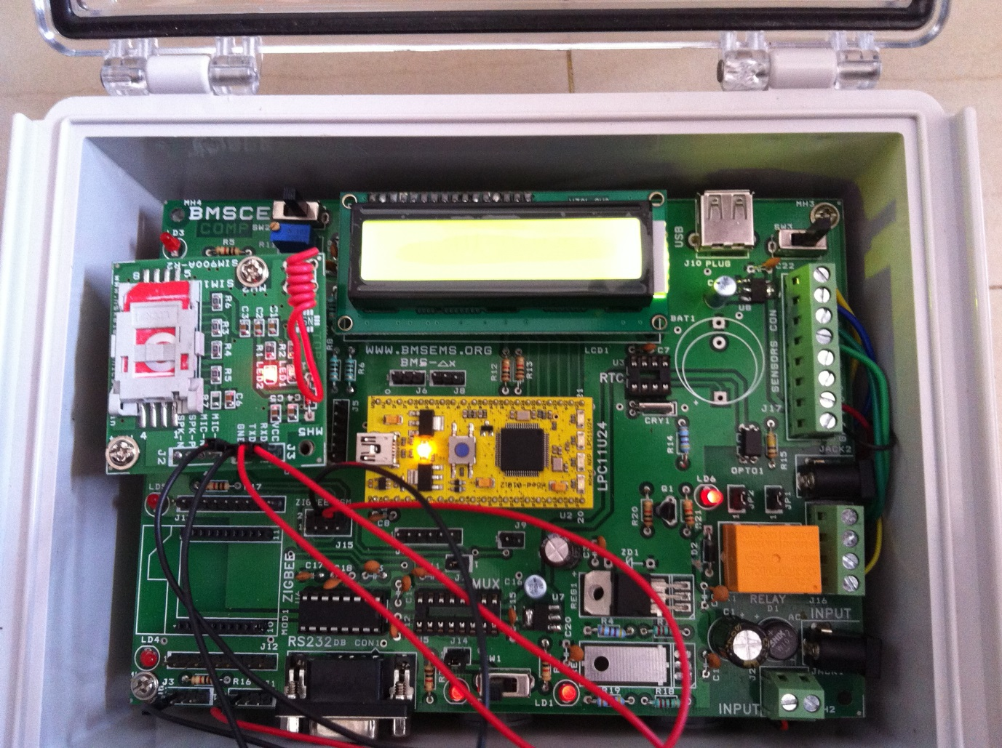

Fig 3.5 Final Working module on a PCB

Aprofessional circuit board on a PCB was fabricated as our need exceeded a higher level of working and demonstration. The whole PCB was in turn capsulated within a water-proof and temperature proof box of certain level as per the IP65 standard for our requirement was in real-time natural farms located across the globe.

## 3.6 SOFTWARES:

1. System Software

|  |  |  |  |
| --- | --- | --- | --- |
| Sl.No | Components | Reason for selection | Approx. cost |
| 1. | Windows XP/7 OS | Experienced usage | - |

1. Programming/Coding software

|  |  |  |  |
| --- | --- | --- | --- |
| Sl.No | Components | Reason for selection | Approx. cost |
| 1 | Mbed online compiler | C++ coding for ARM MBED board | - |
| 2 | PHP Programming language | Basic web-page language | - |

1. Application Software

|  |  |  |  |
| --- | --- | --- | --- |
| Sl.No | Components | Reason for selection | Approx. cost |
| 1. | Eagle layout editor 6.5.0 | PCB design | - |
| 2 | TMFT | Zigbee Configuration | - |
| 3 | HyperTerminal | Interfacing external modules to computer(PC/Laptop) | - |

Fig 3.5 Tables of software used

## 3.7 Software Layout:

On the other hand simultaneously we developed a model of the project on the PC as a soft format using ‘Eagle 6.5.0’. Though none of us was an expert on the field we managed to learn it and create a schematic and board layout.

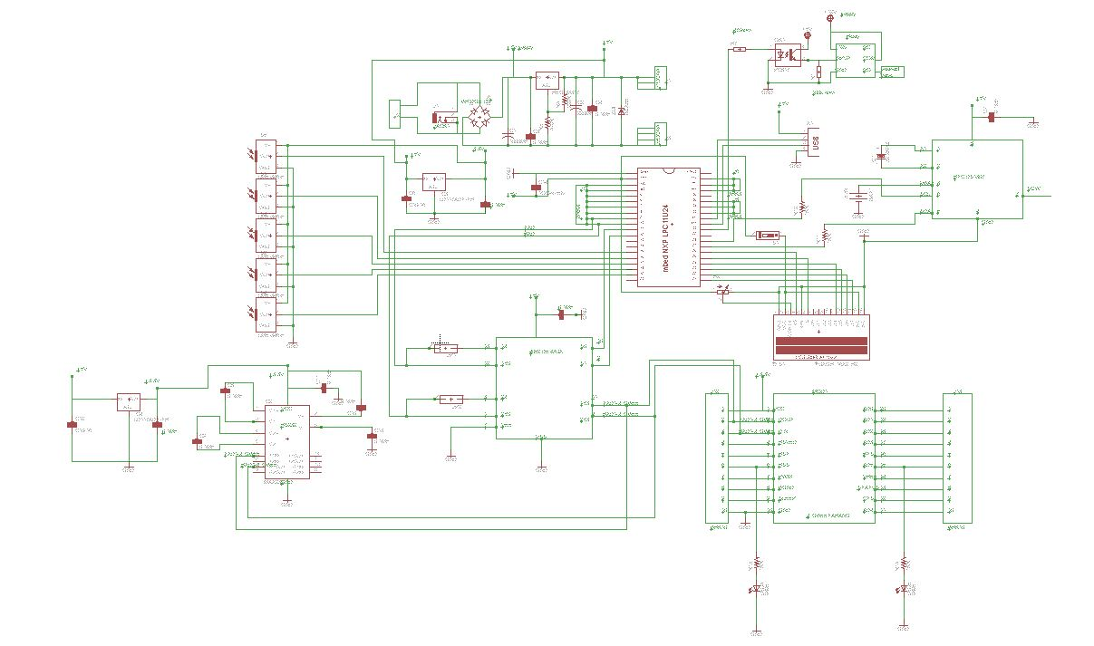

Fig. 3.7(a) FRONT VIEW OF PCB LAYOUT

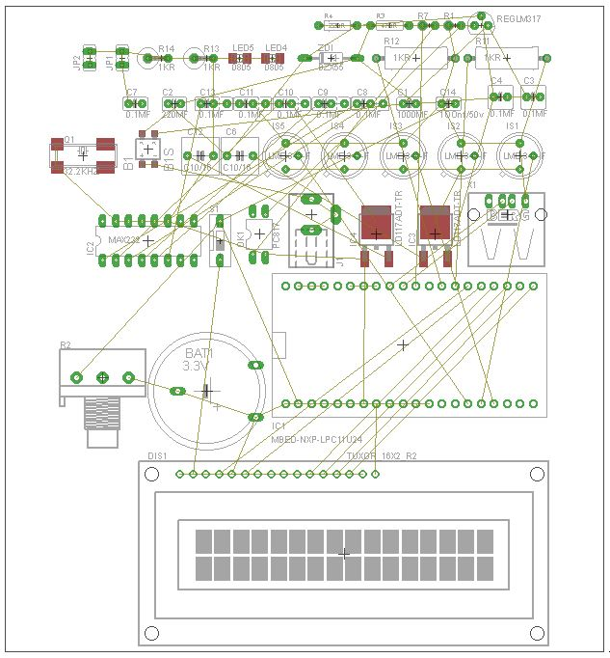

Fig 3.7(b) REAR VIEW

**Fig. 3.8 Code flowchart**

011111

Initialization

**Master**

**Slave**

Supply Power

Supply Power

Read Sensor Values

Read Sensor Values

Display Sensor Values

Display Sensor Values

Soil Dry?

Soil Dry?

Relay ON

Relay ON

Solenoid Valve ON

Solenoid Valve ON

Flash Storage

Flash Storage

Send Data

Receive Data

Data Upload

Condition Critical?

Send Message

Terminate

## 3.8 REMOTE DATA ACQUISITION:

**3.8.1 Web Access:**

### We provide an alternate method of interfacing the output not just with a display but also uploading the parameters to the internet through a GSM Module. Any user in need of knowing the information can log-in with his identity & a distinct secure password and can obtain it.

### 

### Fig 3.8(a) Homepage of the website

### The web-link is: <http://kaems.org/new>

### 

### Fig 3.8(b)Log-in page

Each user is provided with his own distinct ID & a secret password through which he can access the required data.

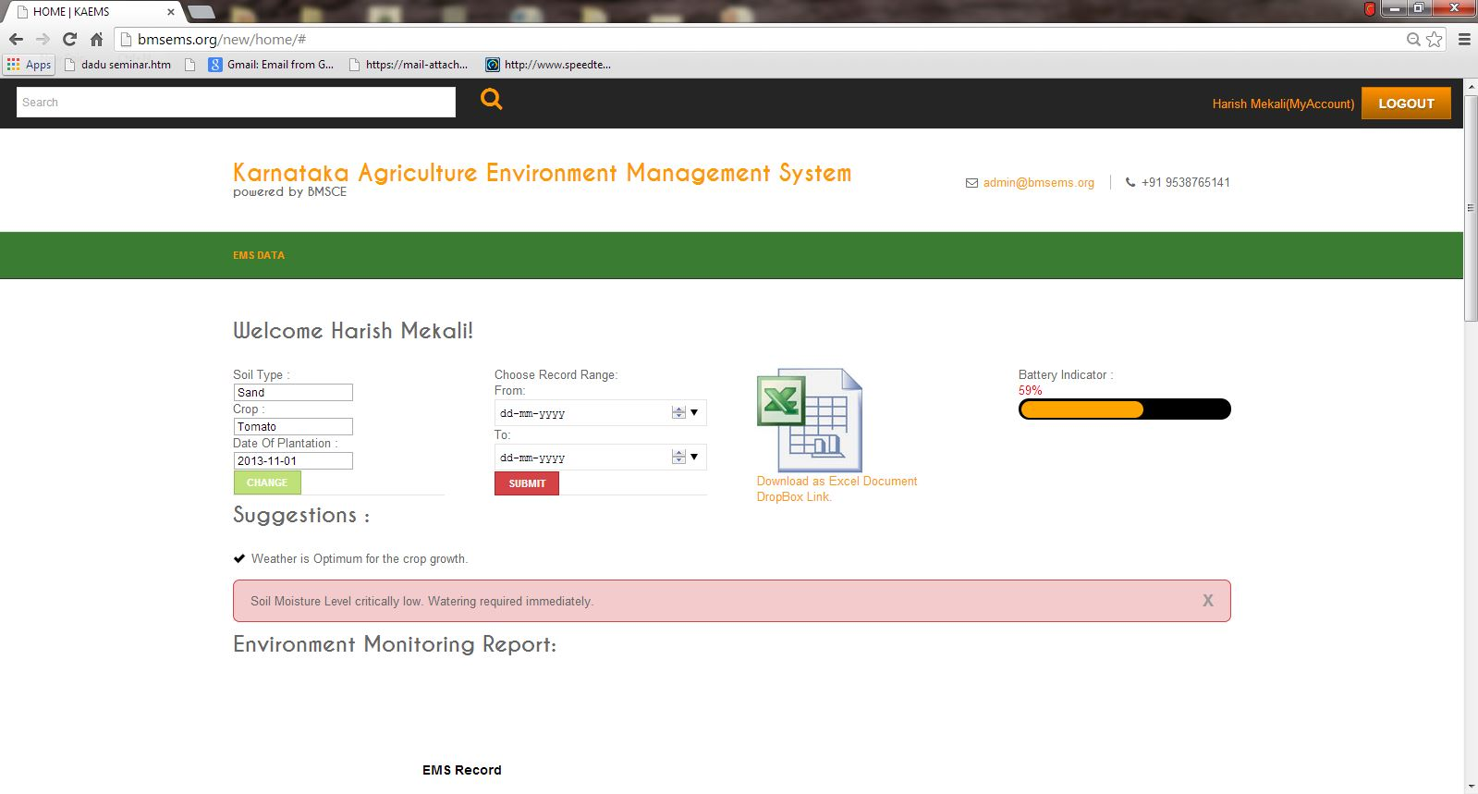

Fig. 3.8(c) User welcome page

The user has to login to the website as a member to access the data or use the website to read the parameter he wishes to get a hold on. For this he has to obtain the permission from the administrator.

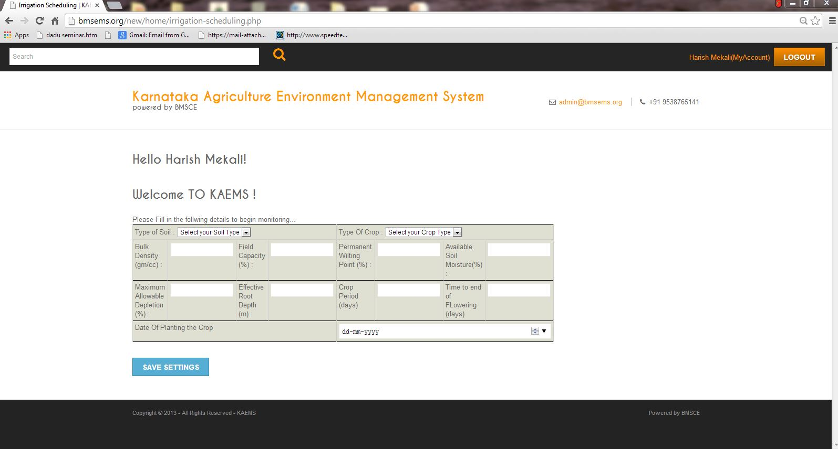

Fig 3.8(d) Webpage of the crop details

Initially we enter the information about soil type, crop and the date of plantation. This information is automatically updated to the database and based on this information our device controls the situation.

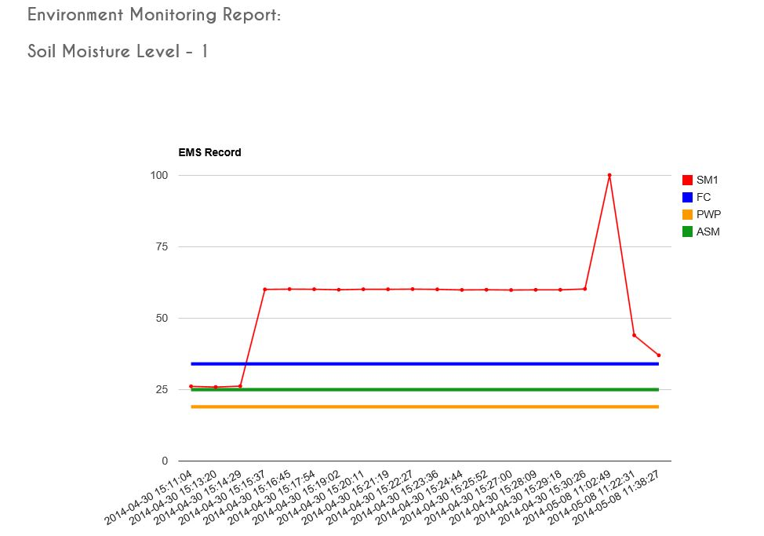

Fig 3.8(e) Graph

A graph displays the various sensor values employed, in detail and the output crop details along with the current battery percentage remaining. 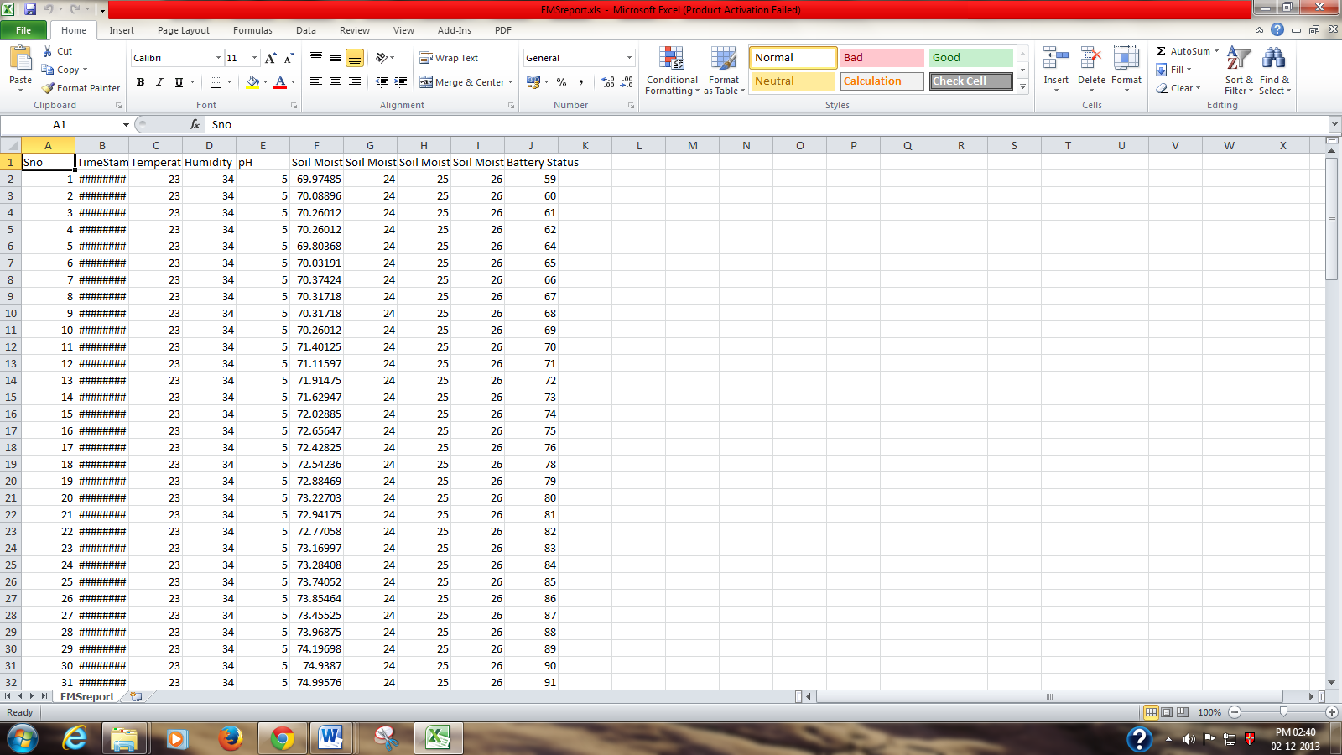

Fig. 3.8(f) Details on an excel spreadsheet

The various sensor data are collectively stored in an excel sheet which can be used later to analyse. The excel files are maintained in an archive format so that less capacity holds maximum amount of information.

**3.8.2 SMS Access**

Though the web access may seem as a solution to global access it needs a quite expensive network connection like the GPRS/EDGE which can sometimes prove to be costly with respect to the farmer.

Hence along with the website access of the project quantities like soil moisture values, field capacity and permanent wielding point, we also accompany with a SMS (Short Message Service) facility as shown in the images below.

We have programmed in such a way that the webpage gets updated with the real time values quite constantly but the messages are sent only in critical conditions, like abrupt change in water level or valve being turned on for a longer time, to name a few.

This was considered because internet access, once stepped into is fixed for a certain time irrespective of the use but on the other hand SMS facility is chargeable with the corresponding count of messages sent.

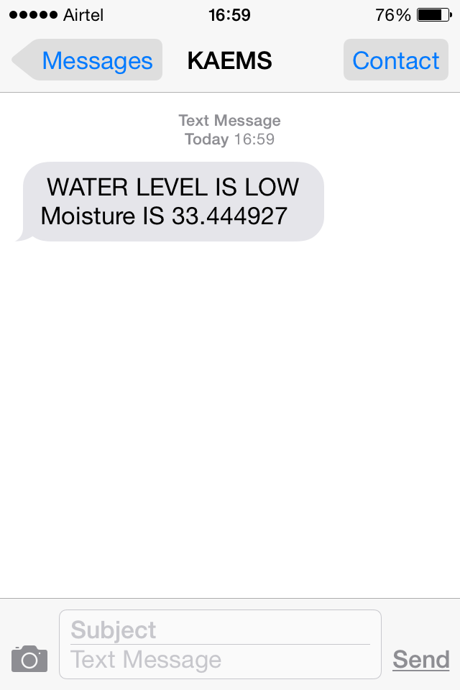

*(Status at time 1)*

1 - Dry Soil

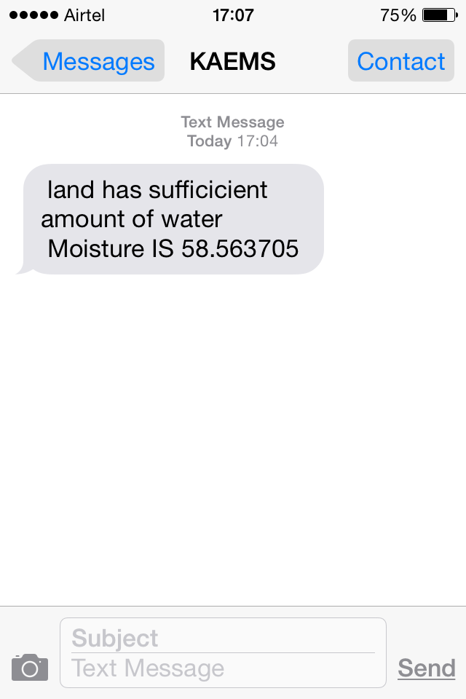

*(Status at time 2)*

2 - Wet Soil

Chapter IV

**CONCLUSION**

Every innovation starts with an idea. Ours started with a cause. A cause towards better society and a better humankind overall.

We proudly propose this idea to enhance the well-being of the farmers who reside at remote places and yet can provision to obtain the knowledge of their fields and crop information. This upgradement of Agricultural System greatly improves the power integrity affordable by the Indian agricultural farmers.

As we began this keeping in mind the ideal mindset of a farmer, so are we ending this with a belief that this project touches the satisfaction level of the same ideal farmer.

We feel glad to conclude that we have touched an effort of few technological fields, sensible utilization of water, making use of modern wireless communication such as GSM, GPRS & ZigBee to name a few.

Developed system proves to be best for prototype but, still some work has to be done on product development to obtain a perfect compatible result.

Each student has contributed his best with the amount of technical knowledge that he possessed combined with his passion to learn further and working innovatively by participating in the project actively.

We firmly believe that our report gives you a fair idea on the project and any suggestions be it on any of the section, feedbacks and criticism are happily accepted.

**RECOGNITION**

Our motivations to mention a few are:

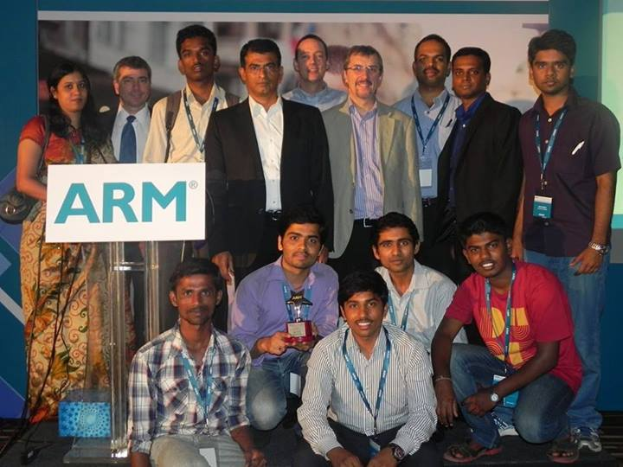

*(2nd runner up in the ARM Symposium held at Le Meridian, Bangalore, in the year 2013)*

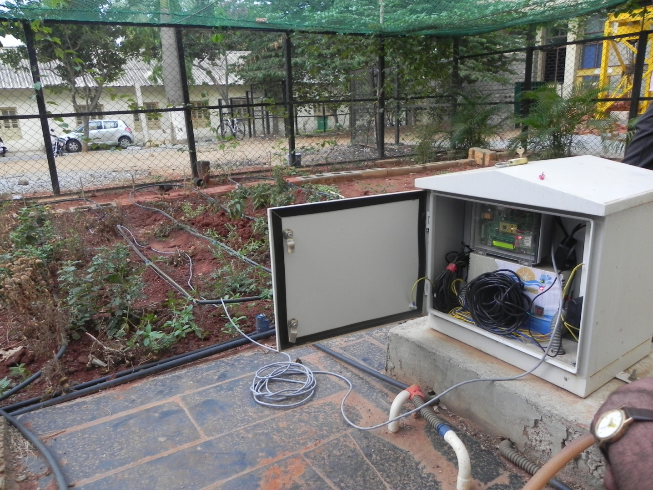

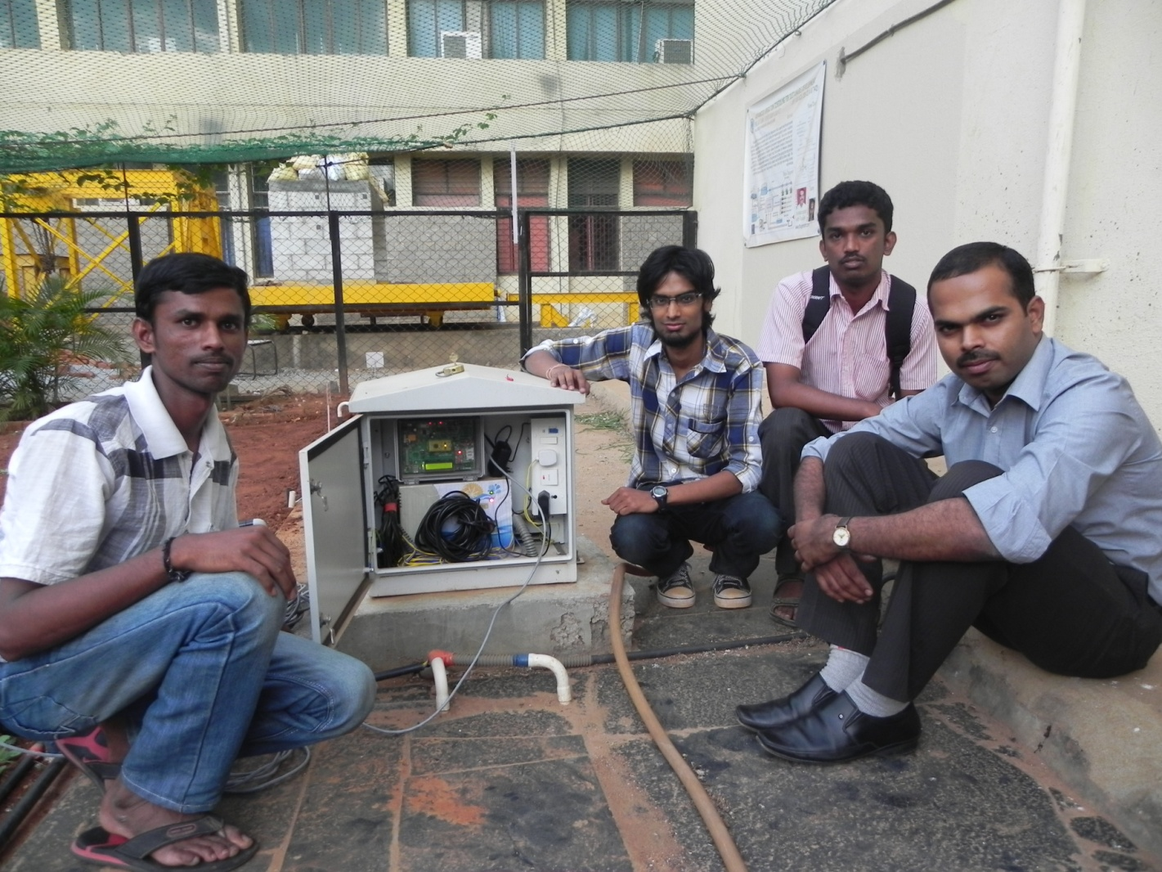

*(Deployment at fields)*

**BIBLIOGRAPHY**

1. ‘[Automated Irrigation System Using a Wireless Sensor Network and GPRS Module](http://ieeexplore.ieee.org/xpl/articleDetails.jsp?tp=&arnumber=6582678&queryText%3Dautomated+irrigation+system+using+a+wireless+sensor+network+and+gprs+module)’

By - [Gutierrez, J.](http://ieeexplore.ieee.org/search/searchresult.jsp?searchWithin=p_Authors:.QT.Gutierrez,%20J..QT.&newsearch=true), [Villa-Medina, J.F.](http://ieeexplore.ieee.org/search/searchresult.jsp?searchWithin=p_Authors:.QT.Villa-Medina,%20J.F..QT.&newsearch=true), [Nieto-Garibay, A.](http://ieeexplore.ieee.org/search/searchresult.jsp?searchWithin=p_Authors:.QT.Nieto-Garibay,%20A..QT.&newsearch=true), [Porta-Gandara M.A.](http://ieeexplore.ieee.org/search/searchresult.jsp?searchWithin=p_Authors:.QT.Porta-Gandara,%20M.A..QT.&newsearch=true)

1. ‘Smart Orchid Soil Moisture Monitoring System Based on Wireless Communication Technology’

By- Ye Na & Liu Junfeng.

1. ‘The optimizing design and application of a new wireless Low-power universal data acquisition system’, By­- Yan-feiai1, yu-jie hao1, jian-ping li1
2. ‘Weather Monitoring System’, Project report – 2013 batch

**ANNEXURE**

**Internet of things**

**Evolution of Internet**

Before we investigate the IoT in depth, it is worthwhile to look at the evolution of the Internet. In the late 1960s,communication between two computers was made possible through a computer network. In the early 1980s the TCP/IP stack was introduced. Then, commercial use of the Internet started in the late 1980s. Later, the World Wide Web (WWW) became available in 1991 which made the Internet more popular and stimulate the rapid growth. Web of Things (WoT), which based on WWW, is a part of IoT. Later, mobile devices connected to the Internet and formed the mobile-Internet. With the emergence of social networking, users started to become connected together over the Internet. The next step in the IoT is where objects around us will be able to connect to each other (e.g. machine to machine) and communicate via the Internet. Figure 1 illustrates the five phases in the evolution of the Internet.

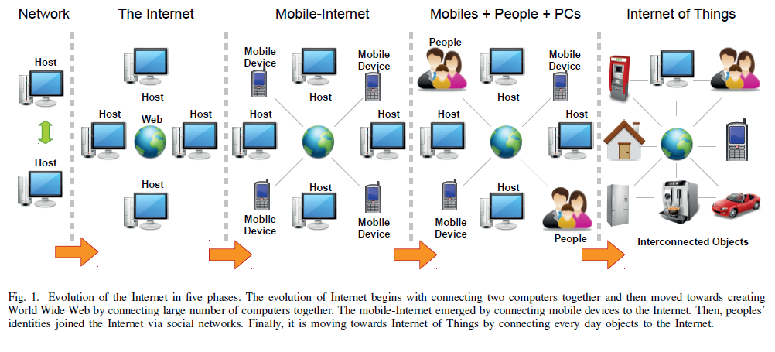

**What is IOT?**

The Internet of Things (IOT) is a scenario in which objects, animals or people are provided with [unique identifiers](http://whatis.techtarget.com/definition/unique-identifier-UID) and the ability to automatically transfer data over a network without requiring human-to-human or human-to-computer interaction.Taking a closer look, we see different types of devices comprising different types of networks that can communicate with a variety of applications over the Internet. These applications may have multiple interfaces. These device networks connect with the Internet and then communicate with the applications via a backhaul network. This backhaul network is the communications backbone of the Internet infrastructure.

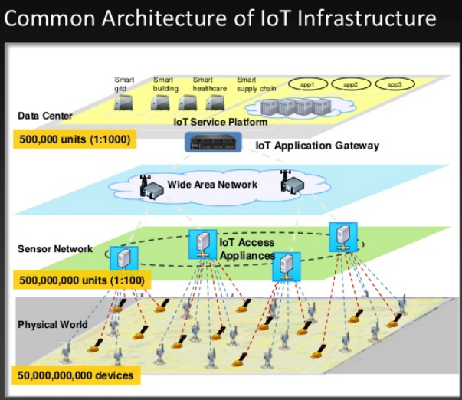

**Fig-basic IOT architecture**

At the lower level of architecture of IOT consists of many sensors which are used to get the data from environment and from physical conditions these several sensors connected to any single home appliances .the data which is collected from appliances is transferred the data to the internet through WAN.

Where WAN provides long distance transmission of data, image, video information over a long distance or large geographical area that may comprises even a country. A WAN can be complex as the backbone that connects the IOT access appliances to the internet.

Gateways are also play a very important role in connecting different network protocols. In case ofIOT connecting WAN protocol to the internet.

**IOT IN AGRICULTURE**

The architecture of accurate measurement and control of farmland irrigation system with IOT is shown in below, in whichapplication layer. Three-tier structure of IoT can guarantee the collection, transmission and real-time processing for the farmland environment data. Sensing layer comprises the router and coordinator nodes deployed in the area of the farmland information collection by Zigbee wireless self-organization network. The router and coordinator not only have communication function, but also can collect the information of the environment, such as the air temperature and humidity, light intensity, soil moisture and so on.

Network layer comprises the gateway node, GPRS network and Internet. The message of the farmland environment parameters can be sent to the monitoring terminal through the network layer. The gateway node includes sink nodes and gateway part. The part of sink node can receive the information from the sensing layer and sends it to the gateway who will pass the information to Internet through GPRS mode. Application layer is composed by the remote monitoring terminal. When the monitoring terminal join the Internet, the managers can monitor the agricultural information collected at any time and place, do some real-time tracking and analysis on the crop growth status and take appropriate control measures according to the environmental to achieve precise control of water.



**Fig- IOT in agriculture**

**Software design**

The system software includes site monitoring system data acquisition software, remote data acquisition receiver software, and web application software. The site monitoring system data acquisition are made up of user interface module, network communication module, data collection module, data processing module and system configuration module. Remote data acquisition receiver is made up of user interface module, network communication module, system configuration module, and database access module, whichcan communicate with the site monitoring system data acquisition software through the network communication module with TCP/IP protocol. The web application software include three parts of user authentication, data access, data query and download, which access the database through ADO.NET, and the remote data acquisition can communicate with the database through ADO.NET. The userterminals can get the real time monitoring data from the web.

In order to ensure a reliable long distance data transmission, the system collects the data through the wireless module access to Internet using wireless transmission technology. The data is connected to the specified network database server, and the software in the database server will receive the sending data through the socket. The data are verified its legitimacy

and stored in the corresponding table in the database.

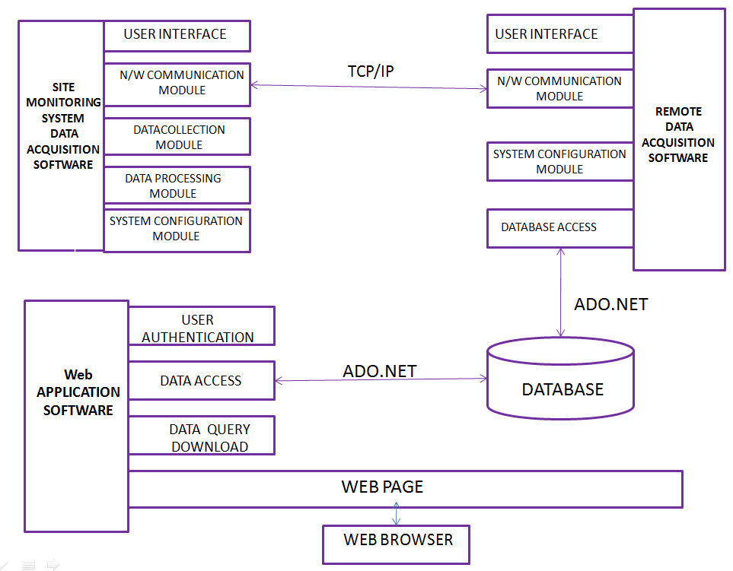

**Fig-IOT access software model**

**APPENDIX**

***Datasheet of Opto-coupler PC817-***

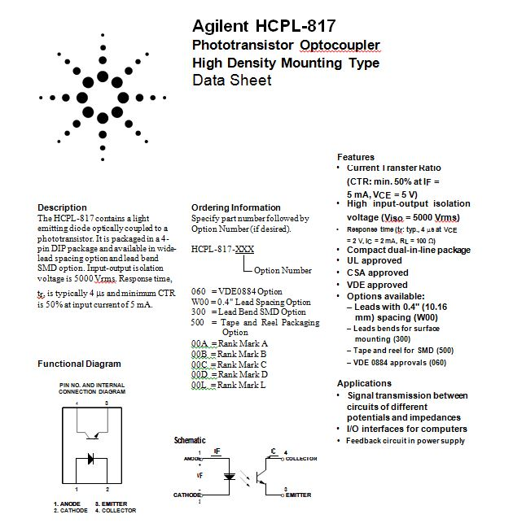

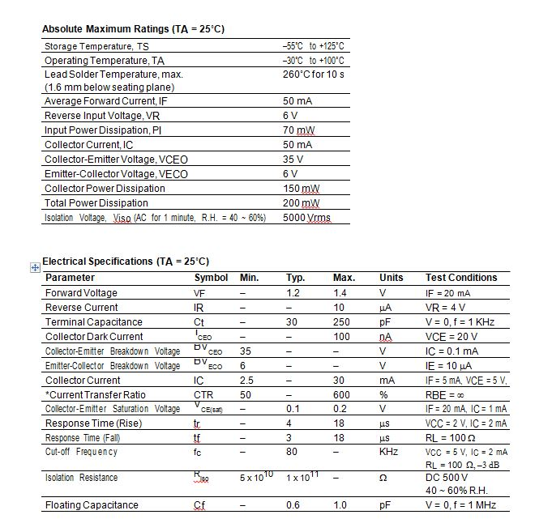 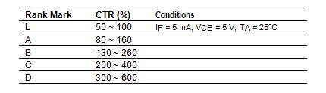

***Datasheet of HRS4 (H) Relay-*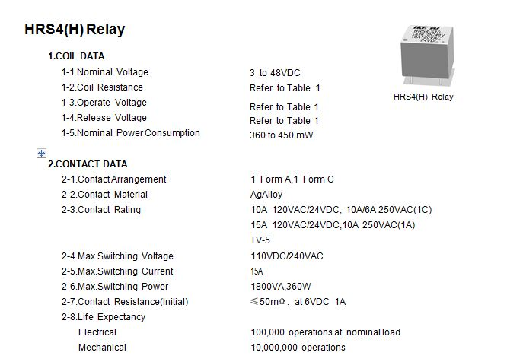 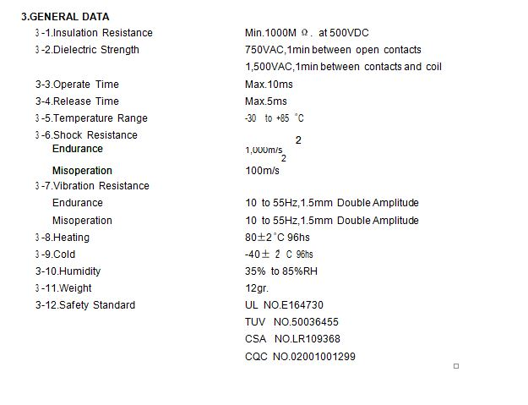**

***Datasheet of MelangeTarang f4 Zigbee Module-***

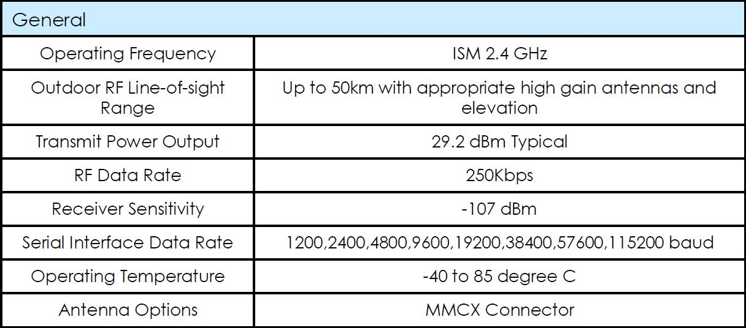

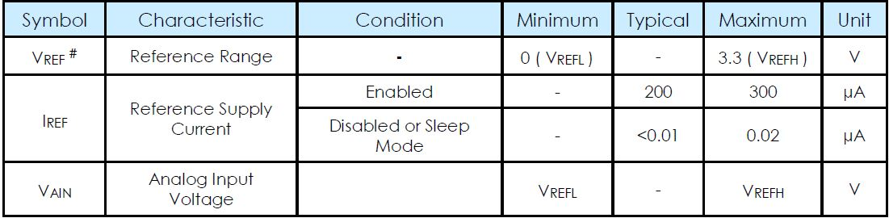

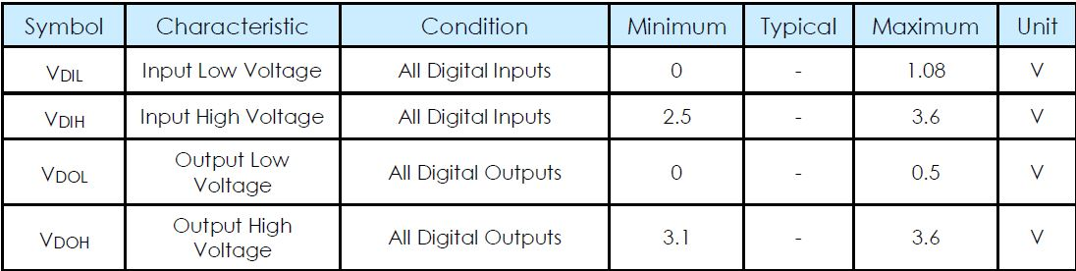

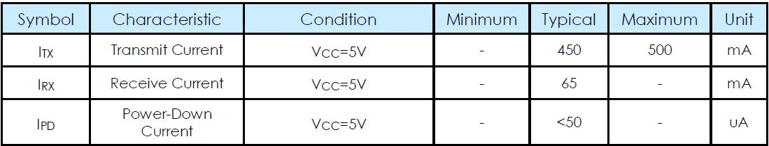

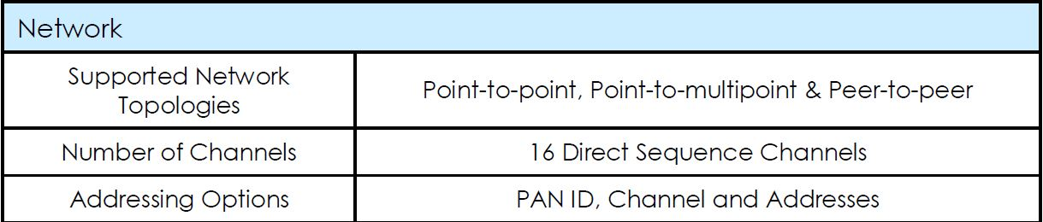

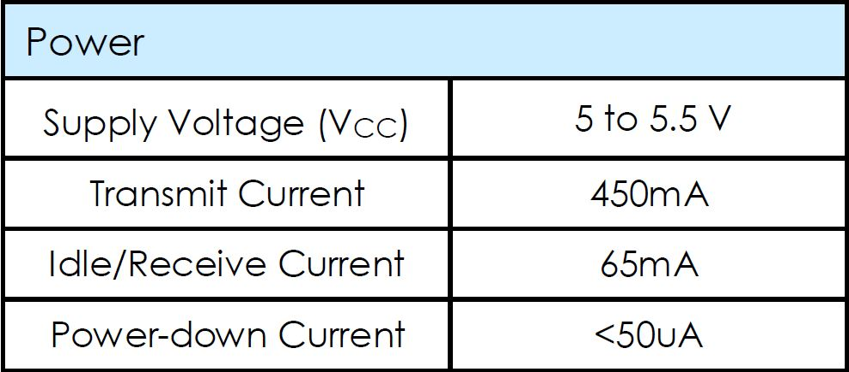

***Datasheet of Real Time Clock-***

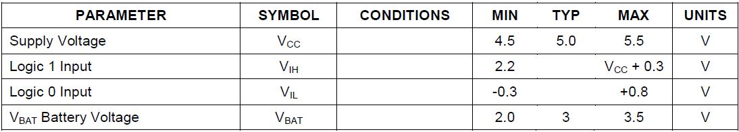

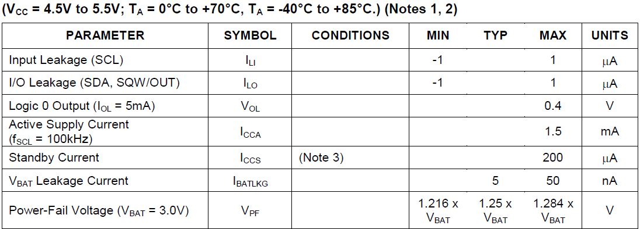

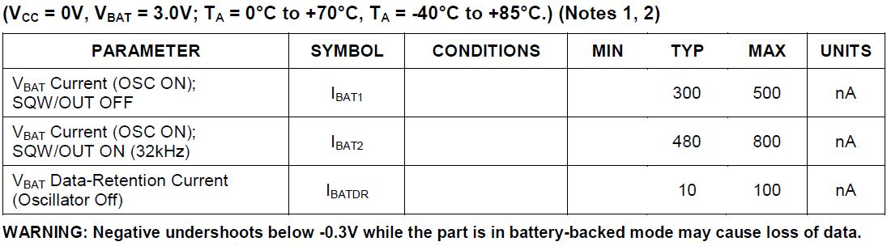

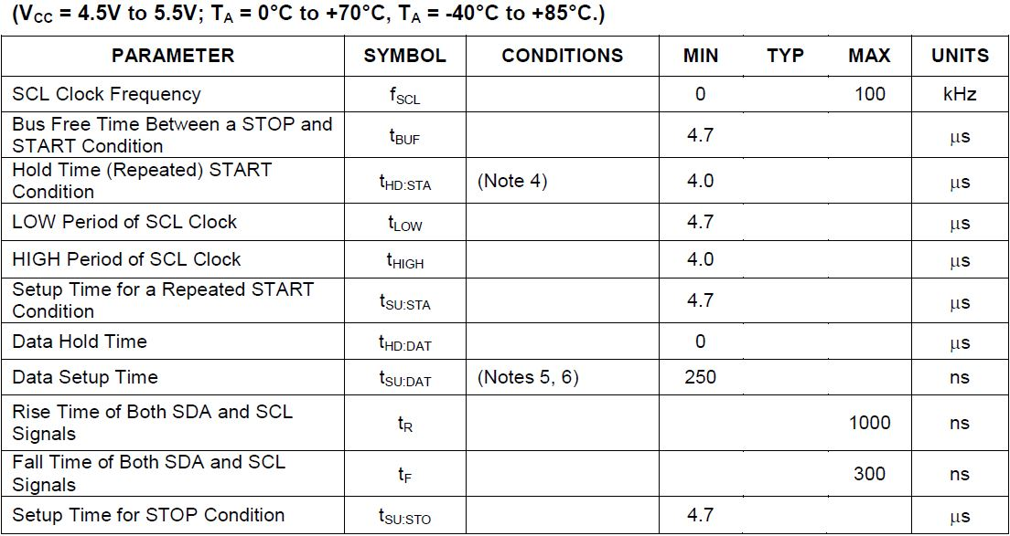

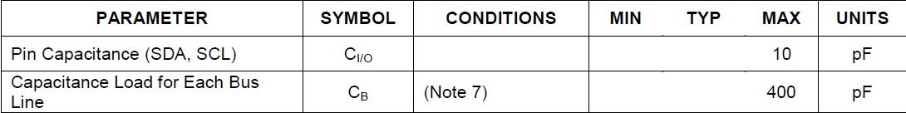

**COMPONENTS LIST**

Hardware

1. Microcontroller board

|  |  |  |  |
| --- | --- | --- | --- |
| Sl.No | Components | Reason for selection | Aprox cost |
| 1. | ARM MBED Cortex – M0 LPC11U24 Microcontroller | 1. Ease of programing 2. Sponsored by ARM 3. Low power | Rs. 2500/- |

1. Power supply

|  |  |  |  |
| --- | --- | --- | --- |
| Sl.No | Components | Reason for selection | Aprox cost |
| 1. | 12v-2Amp AC/DC adapter | Used as a power source | Rs. 150/- |
| 2. | 7.4v-2Ah Lead- ion battery(rechargeable) | Rs.800/- |

1. RF(GSM) module

|  |  |  |  |
| --- | --- | --- | --- |
| Sl.No | Components | Reason for selection | Aprox cost |
| 1. | SIM900 (RS232) | Ease of interfacing /GPRS enability | Rs. 1000/- |

1. Sensors
2. Soil Moisture

|  |  |  |  |
| --- | --- | --- | --- |
| Sl.No | Components | Reason for selection | Aprox cost |
| 1. | VM100 | To measure soil moisture(Non corrosive and water proof) | Rs. 3000/- |

1. Switching devices

|  |  |  |  |
| --- | --- | --- | --- |
| Sl.No | Components | Reason for selection | Aprox cost |
| 1. | Relay | To drive solenoid valve | Rs. 40/- |
| 2 | Solenoid valve | Ease of use | Rs. 350/- |

1. Display device

|  |  |  |  |
| --- | --- | --- | --- |
| Sl.No | Components | Reason for selection | Aprox cost |
| 1. | Liquid Crystal Display -16x2 | Experienced usage | Rs. 130/- |

1. Miscellaneous components

|  |  |
| --- | --- |
| Sl.No | Components |
| 1 | Wire cutter |
| 2 | Switches |
| 3 | Wires (Single strand and Multi strand) |
| 4 | General PCBs |
| 5 | Multimeter |
| 6 | Resistor Set |
| 7 | Buge wire |
| 8 | Bread board |
| 9 | Battery holder |